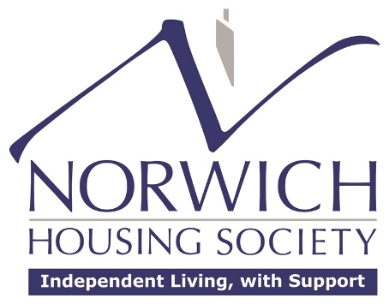

Annual Complaints Performance and Service Improvement Report (2024/2025)

Governing Body’s Response (at meeting held on 23rd June 2026)
The Board met on 23rd June 2026 and their response to the complaints performance and improvement report is as follows:
“The members were satisfied with the performance on managing complaints in 2024/25, noted the key themes from the report and ratified the improvement plan for 2025/26.”

