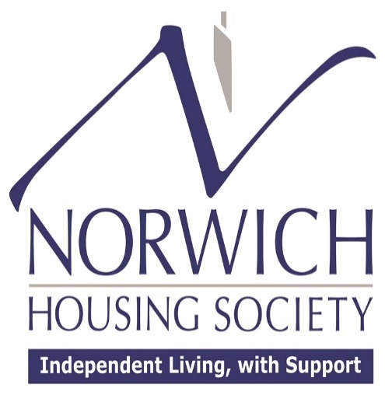

Annual Complaints Performance and Service Improvement Report: 2024/25

Introduction:
This report provides an update on the Society’s complaints performance for financial year 2024/25 and sets out the changes we have made because of the learnings from complaints.
Our purpose is to improve the lives of our residents by providing safe, secure, warm affordable homes and cohesive communities.
Complaints help us do this by providing a way of learning from issues raised and giving us an opportunity to resolve issues in a fair and reasonable way to the satisfaction of our residents.
Throughout the year we have worked closely with our Tenant Advisory Group and a tenant representative on the Operations Sub Committee to make improvements to our services, policies and procedures.
This report covers:
- an update on the recent changes to the Housing Ombudsman Code
- our self-assessment against that code
- a summary and overview of the complaints we have received
- performance information on responding to complaints
- the learning from complaints and the improvements we plan to make in the coming year.
The Society has made good progress in key performance areas which is reflected in very positive feedback from the Tenant Satisfaction Survey carried out in 2023/24 where general resident satisfaction overall was 94.2%.
In the coming year we will be guided by our 5-year strategic plan (2024 to 2029) which clearly shows our commitment to providing quality homes and achieving high levels of satisfaction.

Housing Ombudsman Code:
The Social Housing (Regulation) Act 2023 empowered the Housing Ombudsman to issue a Code of Practice about the procedures members of the scheme should have in place for considering complaints. The Code became effective from 1 April 2024.
It also placed a duty on the Housing Ombudsman to monitor social housing providers’ compliance with the Code.
The Code clarifies the definition of a complaint, how complaints can be reported, the process that should be followed and the governance structure around complaints.
It also requires the Society to produce this Annual Complaints Performance and Service Improvement Report and evidence compliance with the Code.

Code Self-Assessment:
A detailed self-assessment against the Complaint Handling Code can be found on our website’s publications page.
In summary, this shows that our Complaints Policy and how we deal with complaints is compliant with the Code.

Summary of Complaints Received:
During the year, the Society received 9 complaints of which 9 were Stage 1 complaints and there were no Stage 2 complaints.
There were no complaints that were escalated to the Housing Ombudsman following Stage 2 of the Complaints Procedure.
The tables below show the number of complaints and break down the complaints by operational area:

Stage 1 Complaints Recorded (2024/25)

Operational Area |  | Number of Complaints |  | Percentage of Complaints
Anti-social Behaviour |  | 1 |  | 11%
Responsive Repairs |  | 3 |  | 33%
Access |  | 2 |  | 23%
Staff |  | 1 |  | 11%
Rent |  | 1 |  | 11%
Out of Hours Service |  | 1 |  | 11%
Stage 2 Complaints Recorded (2024/25)
Operational Area | Number of Complaints |  | Percentage of Complaints
There were no complaints | N/A |  | N/A

Complaint Handling Performance:
The tables below show the performance data:

Response to Stage 1 Complaints (2024/25)
Number of Complaints | Responded to within 10 days | Resolved/Closed
9 | 100% | 100%

Response to Stage 2 Complaints (2024/25)
Number of Complaints | Responded to within 20 days | Resolved/Closed
0 | N/A | N/A

Learning from Complaints and Planned Service Improvements:
The Society reports to the Operations Sub Committee 4 times a year and to the Board once a year on lessons learned from complaints and what improvements will be implemented to improve the Society’s service, policies and procedures.
The Tenant Advisory Group have input into service improvements four times a year at structured meetings through reviewing service contracts and help shape our policies and procedures.

The tables below set out the improvement plan for 2024/25:

Operational Area | Learning from Complaints | Planned Service Improvements
Responsive Repairs | - There needs to be clear communication with residents on when contractors will be on site to remedy a repair as a contractor arrived a day early as they were already on site to complete another job. | - If a contractor is on site and can carry out a repair early, they should contact the office or Scheme Manager first who will check with the resident if it is okay to attend early.
Tenancy Management | - There needs to be clear information in the Tenancy Agreement and Resident Handbook on when access to properties may be required by the Society. | - The Resident Handbook is currently being reviewed and there will be a specific section on “Access” included in this document.

Strategic Objectives for 2025/26:
During the coming year the Society will focus on the following:
- ensure that we continue to meet the timescales for complaint resolution, aiming to have 100% of Stage 1 responses within 10 days and Stage 2 responses within 20 days
- continue to work with residents on the Tenant Advisory Group to help improve our approach to complaints management
- continue to work with the tenant representative on the Operations Sub Committee to identify any areas of improvement
- increase customer satisfaction by focusing on effective resolution
- continue to learn lessons from complaints to drive organisational improvement.

